SCIENCE 9
EXPECTATIONS AND COURSE SYLLABUS
TAUGHT BY MRS. HAYLEE VERSHURE
Email: haylee.vershure@isd742.org

Please use the following syllabus and expectation sheet as a reference and guideline to contribute to your success in the classroom.

Our science class will focus on the following main content areas for the rest of the year:
- Electricity and Magnetism
- Chemistry Concepts like atoms, periodic table, bonding, reactions, isotopes
- Geologic Dating
- Plate Tectonics
We will be studying these concepts through some of the following avenues: lab activities, power point notes, visual aids, demonstrations, group and individual projects, research papers, debate activities, worksheets, and more. I like to use a variety of activities to cater to different student strengths and to keep things interesting.

A few classroom expectations (which coordinate with the school’s expectations) include but are not limited to:
- Be respectful of yourself, others, and property.
- Be on time to class
- Be responsible by being prepared to work and learn (see “materials” section below).
- Take pride in your work. Always turn in the best possible work you are capable of completing.
- Do not bring food (including candy) or beverages into the classroom. The one exception to this rule is that water is allowed in clear plastic bottles.
- Please keep cell phones put away during class time.
Violation of expectations may include, but will not be limited to, any of the following actions:
1. Student/teacher conference after class
2. Call or email to parent/guardian
3. Disciplinary referral
4. Conference with student/parent/teacher/administrator

Attendance and Make-Up Work
Regular attendance is crucial for success in this class. Students who frequently miss class often earn a non-passing grade. Please be in class every day if at all possible. When a student has been absent, it is his/her responsibility to collect missed work. A monthly calendar is posted in the classroom as a reference for absent students. Students should refer to this calendar and the file-folder box next to the calendar to collect any missed work. Students will be given two days to complete make-up work for full credit, unless specifically told otherwise. Students handing in make-up work should be sure to write “absent,” along with the date of the absence, at the top of the paper. Students absent the day a test or quiz is given should be prepared to take it before school, after school, or during a study period as soon as possible after their return (two days maximum).

Materials
Students should come to class every day with a science notebook, a science folder (or somewhere to keep worksheets), and a writing utensil. Students will be notified when other items, such as a calculator, will be needed.

Homework and Grading
Daily assignments will be posted on the assignment calendar. It is the student’s responsibility to complete all work on time. I do allow some class time for certain assignments, and I will always give a fair amount of advanced warning for future due dates. Repeated late work will dramatically impact a student’s grade, as more and more points get deducted the later an assignment is. Students who frequently turn in late work will likely earn a low grade. I highly encourage the use of a planner or something similar for students to write down due dates.
Parents are encouraged to contact me via email or voicemail any time they have questions about their student’s progress.

Academic Honesty
Academic dishonesty includes, but is not limited to:
- Cheating on a quiz or test through the use of concealed answers, or by copying another student’s work.
- Copying an assignment or worksheet, or sharing information about an assignment or test.
- Offering to another student the answers to an assignment, worksheet, or test, whether solicited or not, in written or verbal communication.
- Theft of intellectual property such as assignments, worksheets, notes, notebooks, tests, or test answer keys.
- Lying to a teacher about academic activities.
- Failing to indicate quotations taken from a source or failing to identify sources in writing (plagiarism).
- Use of electronic or computer media (Internet) in an academically dishonest manner is prohibited.
Those who violate the Academic Honesty Policy may be subject to penalties including grade reduction (no credit for work that is not the student’s own intellectual work).

Parents/guardians should feel free to contact me at any time with questions or concerns, either by e-mail or by telephone. I am looking forward to a very successful, scientific school year! I am hoping to soon have an internet website up and running where parents and students can check our daily activities and resources, but in the meantime remember to check skyward for grades and progress.
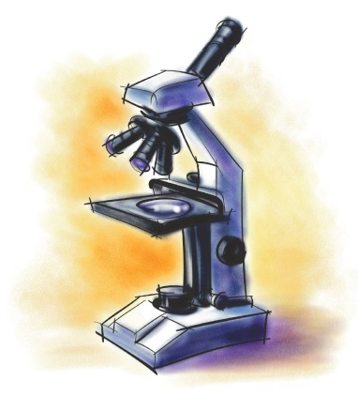

Sincerely,

Haylee K. Vershure
Science Teacher

